

**CLIENT REQUIREMENT SPECIFICATION (CRS)**

**For**

**BASB Automation System**

**(Draft)**

**Version: 1.0**

**Date of Release: February 27, 2016**

**Copy No: 1**

**Prepared by**

**Mijanur Rahman Miraz**

Bangladesh Armed Services Board (BASB), BASB Bhaban, 160 Kakrail, Dhaka

Telephone: +88-02-9336153, FAX: +88-02- 9336153

Email: info@basb.gov.bd, Web: www.basb.gov.bd

**BASB Automation System**

**Bangladesh Armed Services Board (BASB)**

The Client Requirement Specification is a document to describe the need of the client for software development. The document should give input information necessary for the development of the desired software. The requirement normally based on the existing system followed by the organization and likely enhanced requirements to facilitate the objective and mission of the organization. This is basically a primary step for preparation of the “Software Requirement Specification” a complete architecture of the software.

Here, a humble effort for outlining the need of the requirement in very informal way based on the existing system, practices followed by BASB that have been evolved over the long professional practice of long period. The paper has been prepared by Mijanur Rahman Miraz by gathering the information from respective offices by interview, discussions, studying the work procedures.

Covers the Present system in different offices of the BASB starting from Personal Management, Welfare Management, Patient and Medicine Management, Defense Colony Land Management, Micro Credit Loan Management, Shanti Nibash Management, Shashastra Bahini Polly Management, Funeral Management, Archive Management, Accounts and Budget Management, Leave Management, Daily Correspondence Management, Movement Management, Monthly Activities Management, Daily Vehicle & POL Management, Daily Programme Management, Report management etc.

The proposed electronic system is based on the present system and in certain cases on some assumptions. There may be some changes, additions at any time during preparation of Software Requirements Specifications. The paper is not final and will be continuously updated and synchronized.

Mijanur Rahman Miraz, BASB Automation Project takes the opportunity to convey heartfelt thanks to all concern officers, stuffs for their active and positive contributions during visits to respective offices. It’s worth mentioning without their assistance and guidance; it would not be possible to make this paper. I expect similar support in future from all concerned for making the project a success.

Table of Contents

1.0 Scope of the Project 5

1.1 About the Organization: 5

1.2 About the Proposed System: 5

2.0 Overview of Requirements (Software & Hardware) 11

2.1 About the Modules 11

2.1.1 SYSTEM Dashboard 11

2.1.2 User Classification and rights 12

2.1.3 ID Card 13

2.1.4 Personal Management 14

2.1.5 Welfare Management 16

2.1.6 Patient and Medicine Management 25

2.1.7 Defense Colony Land Management 27

2.1.8 Micro Credit Loan Management 29

2.1.9 Shanti Nibash Management 34

2.1.10 Shashastra Bahini Polly Management 36

2.1.11 Funeral Management 38

2.1.12 Archive Management 39

2.1.13 Accounts Management 40

2.1.14 Budget Management 42

2.1.15 Leave Management 43

2.1.16 Daily Correspondence Management 44

2.1.17 Movement Management 46

2.1.18 Policy Letters Management 47

2.1.19 Monthly Activities Management 48

2.1.20 Daily Vehicle & POL Management 49

2.1.21 Daily Programme Management 50

2.1.22 Monthly /Quarterly/ Half Yearly / Yearly Reports Return 51

Management 51

2.1.23 All Application forms USED IN BASB for welfare Activities are attached here 51

2.2 Hardware & Networking 51

2.2.1 List of Hardware 52

2.2.2 Networking with Outlet configuration 53

2.2.3 Data Center 53

2.2.4 Digester Recovery center 53

2.3 Suggested Development Technology and Tools 54

2.4 Suggested testing method for Acceptance 55

2.5 Concept of Security System 58

2.6 Application Architecture 61

2.7 Implementation Activities 62

3.0 Training 63

4.0 Existing Sates and Reports sample as annexure 65

5.0 Deliverables 66

# Scope of the Project

## About the Organization:

Bangladesh Armed Services Board is an organization under the Ministry of Defense (MOD). With the establishment of Armed Forces Division (AFD), control of all aspects except the budgetary, statutory and TO&E matters were vested with the AFD. The role of BASB is to provide possible welfare to the serving and retired persons of Armed Forces. BASB has two tier of administration, one is BASB, functioning as Headquarters and the other is District Armed Services Board (DASB). At the moment, there are twenty DASBs over the country to serve ex-servicemen. The followings are major objectives of BASB:

* To promote the welfare of ex-servicemen and their families.
* To promote and publicise recruiting drives for the armed forces.
* To safeguard the interest of servicemen and their families in matters to be dealt with by the civilian authorities.
* To formulate and sponsor plans for the rehabilitation/re-employment of the ex-servicemen and their families.
* To maintain and administer welfare of charitable fund and institution for the welfare of ex-servicemen.
* To watch that the concessions granted to ex-servicemen and their families are made available to the beneficiaries by the parties concerned.

To achieve the objectives BASB perform the following activities through manual process:

* Manual Processes and Data Capture
* Difficult to get timely and accurate information
* Reconciliation between different reports
* Poor connectivity between locations
* Consolidation of data from different location

## About the Proposed System:

BASB desires to have developed an integrated system which would help them to support their activities by multi –module application software. This will integrate all departmental functions, across BASB into a single automation system. It will automate all the tasks required to perform flawless operation. Objective of automation system are as follows:

* To smooth follow-up of day to day operational activities of BASB.
* To quick response to serve for the welfare of ex-servicemen and their families.
* To establish one stop services by creating online database to maintain and administer remotely for the welfare of ex-servicemen and their families.
* To smooth management of BASB accounts.
* Faster Service Delivery.
* Convert to Paperless office.
* To create a functional database of Reservist.
* To strengthen the capacity of BASB.

**Proposed System:**

There will be following three separate sub-projects.

* MIS system development for BASB.
* Data Center Set-up.
* ID Card Automation.

**Outflow Activities.**

* Every retired personnel’s data will be readily available in the database.
* Once the data is entered the individual will have a ID Card and will be able to use it for any of his requirement concerning BASB/Services HQs/Records.
* The retired person will have an ID card with Barcode.
* Once the data is entered all his related activities when requested/ availed should automatically updated and all concern offices will be able to see the updates.
* PMS will highest security system/ coverage as regards to hacking or loss of data or getting down of site.
* Authority/ Admin should be able to get any report of any individual as and when asked from PMS.
* Respective Office will be able to enter/edit data of individual as and when required.
* The retired persons will be able to monitor the status his application every time after submission.
* Once individual dies his status will be shown in a separate field.
* Data of serving personnel in BASB also will be entered and reports will be as per requirement.
* All authorized person will have Digital Signature provision.
* Yearly Budget will be asked to all sub offices on line.
* All sub offices should forward budget to HQ on line.
* After approval of authority a consolidated budget request will be forwarded to MOD on line.
* Once received budget from MOD to be allotted will the sub offices. Demanded and actual allotment to be shown as per code and sub code.
* The sub offices will forward the bill to the HQ as per prescribed format using digital signature and will have provision of attachment/scanned of necessary papers.
* Once bill is submitted by the sub offices to HQ the allotted amount from concern code will be adjusted as per demand.
* Reconciliation of budget of each month will be automatically.
* It will have provision of revised/additional budget demand. All sub offices will be able to demand for revised/additional budget; accordingly total demand for revised/additional budget will be forwarded to MOD online.
* Once received the revised/additional budget from MOD again this budget will be allotted to all sub offices. This will be adjusted with main budget.
* At the end of the year reconciliation state will be automatically updated.
* Basing on expense every month and quarterly report will be ready automatically.
* Provision of Note Sheet for sanction of any expense of budget will be there.
* Code/Head/Sub Office wise allotment, expense and remaining will be shown.
* There will be Private, RCEL, BSCR, Medical Dispensary, Shanti Nibash, Defense Colony Land, Shashastra Bahini Polly fund state. One is for sources of income and another is for expenses. Provision of NS of sanctioning expense will be there.
* Date wise/ head wise expense will be there.
* Medical Officer will be able to prescribe using data base.
* The sub offices will be able submit their medicine demand on line.
* The total demand will be compiled automatically.
* Total fresh requirement will be automatically ready basing on master stock.
* The treatment history will be available in the individual data base.
* All serving personnel should be able apply for leave on line.
* Automation of welfare activities applying monitoring and follow ups.
* Internal email correspondence, using outlook express and Micro Soft Exchange server.
* Automation of travelling related activities and expenses.
* Internal and external policies, which needs to be archived using structured indexing through document management.
* **Document Management System.**
* Automation of BASB land project outside Dhaka which would be divided into plots and given to members.
* List of monthly activities assigned to district levels which needs to be automated for follow-ups and measure progress of the same.
* Vehicle movement, maintenance and management system.
* Micro credit operation for the members of BASB needs to be automated in such a manner so that status of each customer in terms of payment history, current remaining balance and follow ups and monitoring can be easy.
* Automation of old age home welfare activity of BASB.
* Automation of Shashastra Bahini Polly Management System, a welfare activity for the members of the BASB who needs rehabilitation.
* Automation of events activities for social networking among BASB members.
* Automation of Funeral Management System for the deceased members of the BASB.
* Automation of periodic BASB standard report sets on monthly activities and tasks, resulting generation and circulation of the same.
* Automation of periodic BASB standard report sets on monthly activities and tasks, resulting generation and circulation of the same.
* Automation of periodic BASB standard report sets on monthly activities and tasks, resulting generation and circulation of the same.
* Automation of periodic BASB standard report sets on monthly activities and tasks, resulting generation and circulation of the same.

The proposed system will be a distributed web based system for the BASB MIS Portal.

* Host the site in the BASB Data Center.
* The system will be very easy to manage and upgrade as data entry and reporting modules are web based and accessible using any chrome (version greater than 40) and Mozilla (version greater than 40) and IE (version greater than 9). User support requirements will be less and during system upgrade and bug fixing, just updating the files in the server will suffice.
* Another server should be kept as backup server which will periodically and incrementally be updated / synchronized from the main server. This server will act as a tool for data recovery so that whenever the main server fails – this server’s data can be restored to immediately keep the site up and running.
* The BASB will have internet connection among its District Offices. Generally reports will be html based, but can be exported as pdf, Excel, text or sent as e-mail for further processing and analysis.

System would facilitate organization-wide integrated information systems, covering all functional areas.

* Modular solution with option for phase wise roll out;
* Flexible;
* Easy to add functionalities;
* Technology platform;
* Centralized system for all locations and HO
* Budgetary control with automated workflow of each department
* Consolidating all BASB location automatically;
* Minimize communication gap among departments;
* Reduces cost and process time;
* Standardization and speeding up the process;
* Organization integration;
* Combines all databases across departments into a single database that can be accessed by all;
* Fewer errors;
* Improved speed and efficiency;
* More complete access to information;
* Shorten process times;
* Sustained involvement and commitment of the top management;
* Integration of information using a single data source across the organization;
* Information is available online and real time;
* Overcome inefficiencies of independent systems;
* Minimizes response time;
* High Availability in overall architecture.
* Redundancy in Data Center Network Architecture.
* 24/7 Availability of System.
* Open Network where BASB can deploy any network technology at any time.
* Security for both Intranet and Internet. Through intranet IP Sec VPN and for internet secured socket layer to be deployed. To secure the email transaction, Digital Certificate for each email user is proposed.
* At least 5 years availability of proposed technology
* Direct impact on Retired Person socio-economic life through easy access of services.
* Workflow of each department will be automated.
* Integration of information using a single database across the organization.
* Consolidating the BASB planning.
* Minimize communication gap among departments.
* Reduces cost and process time and improve efficiency.
* Standardization and speeding up the process.
* Organization integration.
* More complete access to information with less error.
* Sustained involvement and commitment of the top management.
* Information is available online and real time.
* Overcome inefficiencies of independent systems.

BASB needs a web portal for applicants to apply for welfare grants and monitor the application status. A comprehensive website for BASB can be designed covering their activities.

**Features would be:**

* Accommodating BASB information and activities;
* Application forms required for the members for obtaining services from BASB for download from website
* Application submission for approval
* Member only areas for Blog and group collaboration
* Informative web portal with all functional activities.
* Group collaboration and communication;
* Member Blog without public access;
* All forms available for download;
* Member communication with support team using predefined contact form.

**Web portal.**

* BASB needs a web portal for applicants to apply for welfare grants and monitor the application status.
* A comprehensive website for BASB can be designed covering their activities.

**BASB will set-up a centralized email System in this project.--- Need a bit clarification**

* Platform will be Microsoft Exchange Server/ developed mail server
* Email for all users
* All email will be backup in central Storage System
* Digital Signature will be implemented for all email users for Authentication.

**Other Outputs.**

* Identical information across the organization.
* Presentation of information as required by HQ/ Donors.
* Routine correspondence automation.
* Electronic communication will minimize paper and file management.
* Members can be easily reached with events and social activities.
* Informative web portal with all functional activities.
* Group collaboration and communication.

# Overview of Requirements (Software & Hardware)

## About the Modules

### SYSTEM Dashboard

Provide all the Stakeholders / entities with appropriate authorized access to Working Dashboards for relevant functions of the System. DASHBOARD will be operating platform for all users to use the system.

**General**

* Dashboard to be developed gradually and menus to be activated after launching the modules.
* Essential forms, circulations, news bulletins, important links may be available.
* Remaining may be shown under construction.
* Mail service with users and connected to external services.
* Chat facilities within the stakeholders.
* The dashboard will contain graphs, charts & maps and when drilled down will show detailed information.

| **User Class / Actor** | **Characteristics** | **Responsibilities** |
| --- | --- | --- |
| Admin | * Can do limited job in the system | * Create, edit and change local user |
| Super Admin | * Can do any jobs in system | * Add, modify and delete all information. * Give permission to all users and documents. * Manage the user authentication layer. * Create & assign role to users. * Manage application security. * Manage application settings. |
| Section User | * Can do assigned task in the system | * Open task box * Forwarded to the specific user with supporting reference |
| Section Officer | * To assist to take decision through system | * Give decision on assigned task * Obtain decision on specific task through system * View and monitor report and activates * Assign task of subordinate through system |
| Deputy Director | * To assist to take decision through system | * Give decision on assigned task * Obtain decision on specific task through system * View and monitor report and activates * Assign task of subordinate through system |
| Director | * Taking decision through system | * Give decision on any task * View and monitor all reports and activates * Assign task of subordinate through system |

### User Classification and rights

### ID Card

**Existing Business Process:**

**Overview:**

To operate official activity smoothly, the authority of BASB took decision to ensure ID card for all officials. Allocation of serial number of ID card has certain algorithm. For obtaining an ID card out of six categories from BASB office, applicant needs to submit application with photograph. The expense of preparing ID card of first time is to be paid by BASB offices.

The following information is covered by an ID card:

* Svc No
* Rank
* Name
* Trade
* Name of Office
* Date of Birth
* Blood Group
* 2 X signature (Card Holder and Signature of Authority)
* Photograph

**To be System:**

* System generated card will be produced ensuring all required information using barcode.
* Attendance will be managed by auto generated card.
* Different type of state and report (as per requirement) will be generated through system.

Following features can be considered during development:

* Assess BASB’s needs properly and Compliance policy.
* Acceptable design.
* Ensured maximum Security Levels and Authentication.
* Biometric authentication can be implemented.

### Personal Management

**Existing Business Process:**

**Overview:**

About 164 personnel are working on BASB & DASB offices and a huge number of personnel are getting welfare support from these offices. The beneficiaries live around the over country. At present this office is having 42 sub Offices to provide the Welfare Support to the beneficiaries.

**To Be System:**

**Overall:**

Personal management is following two types:

* Personal management system for serving personnel
* Personal management system for ex-serviceman

There are following items can be ensured by the system:

BASB intends to develop a biometric authentication supported system to verify its members and inherent.

* Data Capturing (Personalized and biometrics);
* Verification of data;
* Authentication;
* Implementation with related modules and system;

Outcome of Personal Information Management:

* Easy to identify members;
* Service delivered to deserving members;
* Inherent /Spouse identification;
* Memorial Service Management

**Personal management system for serving Personnel:**

* Serving Personal Data Management
* Service Management
* Recruitment / Applicants Management (If Any)
* Career Management
* Attendance Management
* Employee Contracts Management
* Documents (Serving Personnel) Management
* Training Management
* Management of Posting/Promotion/Appt /Mission /STMK of all ranks
* Keeping record of posting / release etc for Unit

**Personal management system for ex-serviceman**

This module will help to manage and maintain records of ex-serviceman. It helps to add/edit personal information, family information, and job history information.

Some of features will be as under:

* Create/modify personal information
  + - Create/modify educational information
* Create/modify family information
  + - Create/modify children information
    - Create/modify spouse information
* Create/modify job details information

Common feature of the proposed system:

* + - Every retired personnel’s data will be readily available in the data base.
    - (Once the data is entered the individual will have a ID Card and will be able to use it for any of his requirement concerning BASB/Services HQs/Records.
    - The retired person will have a ID card with Bar code.
    - Once the data is entered all his related activities when requested/ availed should automatically updated and all concern offices will be able to see the updates.
    - PMS will highest security system/ coverage as regards to hacking or loss of data or getting down of site.
    - Authority/ Admin should be able to get any report of any individual as and when asked from PMS.
    - Respective Office will be able to enter/edit data of individual as and when required.
    - The retired persons will be able to monitor the status his application every time after submission.
    - Once individual dies his status will be shown in a separate field.
    - Data of serving personnel in BASB also will be entered and reports will be as per requirement.
    - All authorized person will have Digital Signature provision.

### Welfare Management

#### Bangladesh Serviceman Charitable Relief Fund (BSCR)

**Existing Business Process:**

**Overview:**

BSCR is one of the major activity of welfare branch of BASB. Ex- Bangladesh Serviceman, ex- British servicemen and their spouses is prime beneficiary of this welfare service. At present this service is running over countrywide through DASB offices. Usually DASB offices receive applications from ex-serviceman or their spouses and forwarded to HQ-BASB with recommendations of respective DASB Secretary. After receiving all applications from DASBs within three months and checking all conditions as per policy, HQ BASB official prepares a possible list for placing to periodical meeting of concern committee. A standing committee headed by Director of BASB will select individual or family who will able to get financial help after preparing a board proceeding. The sources of fund of BSCR are pre-defined as per initial instruction. The following major conditions are strictly maintained by concern authority while giving sanctions:

* Applicant must be the member of ex-Bangladesh Serviceman or British servicemen or their spouse
* Applicant will be eligible to obtain financial help single time only for each consecutive three years.
* One family will get highest BDT 5000.00 per sanction but it would be highest BDT 20000.00 in special case on prior approval of AFD.
* Total yearly financial help will not be exceed more than BDT 10,00,000.00 but considering special case, it might be gone up to BDT 15,00,000.00.
* The fund will be auditable by internal audit team after each three months and audit board will be formed by Director, BASB. Besides, government audit team will also check all transactions done by the board of officers.

**Major Actors**

* Ex- Bangladesh Serviceman, ex- British servicemen and their spouses
* All DASB Offices
* HQ- BASB
* Banks
* A Standing Committee consisting three members
* Concern Record offices
* Bangladesh Army Welfare Directorate

**Cross Functional Diagram**

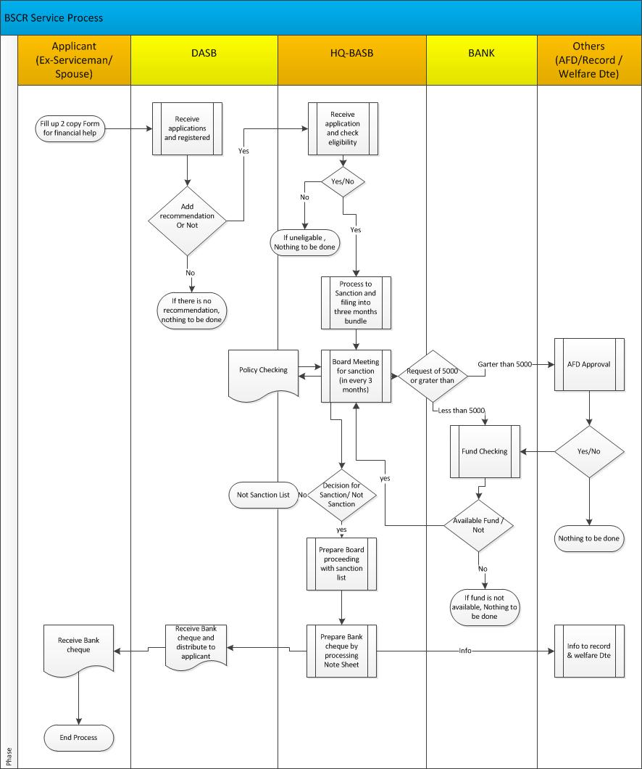

#### RCEL (Royal Commonwealth Ex-Services Leage)

**Overview:**

The Royel Commonwealth Ex-Services League (RCEL) provides welfare support for ex-serviceman and women of commonwealth countries who have at some time reserved the British crown and residing in Bangladesh (For Bangladesh). Those Bangladeshi soldiers who reserved in British crown before 1947 are eligible to get the RCEL grant. If soldier is not alive, their alive widow will get the grant. After receiving the filled up form concern DASB will verify and forward to BASB HQ. A Board composed at BASB HQ will be finally recommended for approval. Director, BASB will than approve. After approval of Director, Check will be issued to the individual through concernDASB.

**Following major steps to get grant:**

* The eligible applicant to collect the form from concern DASB/on line from BASB website.
* After filling the form submits to concern DASB/online submit to concern DASB.

**Necessary documents are required during submission of application:**

* Pension Book (photocopy)
* National ID card (photocopy)
* Photo (passport size) – 02 copies
* Chairman certificate -01 copy

**Major following task are under this activity:**

* Policy Preparation for operating RCEL activities
* Meeting arrangement
* Gen Corres like application receiving , preparing board proceeding, note sheet etc
* Process RCEL Demand
* financial Help sanction
* Visit corres
* Prepare different type of state

#### GRANT OF DISTRESSED ALLOWANCE

GRANT OF DISTRESSED ALLOWANCE (DUSHTO BHATA) is a welfare activity of BASB. Only the under mentioned persons are entitled to receive Distressed Allowance (Dushto Bhata). Widows of Ex-armed Forces Personnel of Bangladesh Army, Navy and Air Force including released and retired personnel of British, Indian Armed Forces and Pakistan Armed Forces are eligible to get this grant. Besides, widow wives of Shaheed/Deceased Offrs, JCO, OR, NC(E) and MODC personnel are also eligible to get this grant. Only the citizens of Bangladesh are entitled to receive Dushto Bhata. The under mentioned widows are not entitled to receive Sena Kalyan Sangstha Distressed Allowance:

* Widow wives of dismissed personnel from the Armed Forces services.
* Widows of Ex-Recruit and income earning wives.
* Widows of Ex-members of BDR, Ansar, Mujahid, Police etc.
* Widows receive such Bhata from Govt.

Eligible person can collect Application Forms available free of cost with HQ BASB, all District Armed Services Boards and Sena Kalyan Sangstha’s Head Office at Sena Kalyan Bhaban producing their husband’s pension or discharge book. An applicant will fill-up section one of the application form correctly with connected certificate/papers are mentioned at para-11 of the form and will submit to the concerned District Armed Forces Board for verification and signed by the Secretary DASB. After putting signature of Secretary DASB, the file will be forwarded the application to the concerned Record Office of the late husband of the applicant for verification/ratification and onward to AHQ¸ AG Br, Welfare Dte for necessary approval. During scrutiny, DASB/Record Office will look into the followings:

* Whether the widow applies for Distressed Allowance (Dushto Bhata) actually wife of late Offrs, JCO, OR, NC (E) and MODC personnel.
* Whether the widows receiving family pension as the wife of late Offrs, JCO, OR, NC (E) and MODC personnel.
* Authority concerned may inquire the cases whether the widow get remarried or not.
* Considering the above applicant widow is eligible or not for granting Dushto Bhata.

Dushto Bhata yearly rate is Tk. 2,000.00 (Two thousand) only, Postal and Stationary charge is Tk. 100.00 (One hundred) only per widow. Sanctioned amount will be sent to the Welfare Directorate of three services (Army, Navy and Air). They will send to concerned Record Office to distribute among the widows. Widows are required to apply once. For subsequent years she will submit a non-marriage certificate from local Chairman that she does not get remarried. An award is liable to be forfeiture at any time if she furnishes wrong/false information. Committee for awarding for distressed allowance (Dushto Bhata) is as under which will be held in the month of April each year.

##### VETERAN ALLOWANCES

The system for granting veterans allowances for Ex-Armed Forces Personnel is as follows. Ex-Armed Forces Personnel of Bangladesh Army, Navy and Air Force including released and retired personnel of British, Indian and Pakistan Armed Forces Offrs/JCO/OR/NC(E) and MODC personnel of the age of 70 (Seventy) and above years old 65 years in case of injured persons in CHTs. Following persons are not entitled to receive the allowances:

* Dismissed personnel from the Armed Forces Services
* Ex-Recruit
* Ex-members of BDR, Ansar, Mujahid, Police etc
* Wife, sons and daughters of Ex-Armed Forces Personnel

Application Forms will be available free of cost from HQ BASB, all District Armed Services Boards/CORO and Sena Kalyan Sangstha’s Head Office at Sena Kalyan Bhaban, by producing their pension or discharge book. An applicant will fill-up part-I of the application form correctly and will be forwarded to concerned District Armed Services Board with connected papers for their verification. On completion of part-II, necessary verification and signed by the Secretary DASB/CORO will forward all the papers to concerned Record Office. Record Office will complete part-III and will forward to Welfare Directorate of concerned services HQ with the opinion of OIC Records for final decision. Concerned Record Office will scrutiny the following documents:

* Correctness of date of birth as per discharged book/school certificate. Whether the applicant is eligible for veteran’s allowances on the basis of documents and condition.

**Rate of Allowances**

Rate of Veteran Allowance and postal and stationary charges are as under :-

* Officer Tk. 1000.00 Per Month
* JCO Tk. 700.00 Per Month
* OR Tk. 500.00 Per Month
* Postal and stationary charges Tk. 100.00 Per Month

Sanctioned amount will be sent to the Welfare Directorate of three services (Army, Navy and Air). They will disburse to concerned Record Office/CORO for disbursing to the veterans. Sanctioned amount will be forwarded to the veterans by name through bank draft in favour of the same bank from where the individual receiving his pension. Once an applicant receiving veteran’s allowances for subsequent year he does not required to apply again. He will submit a certificate from the local Chairman that he is alive. Applicant will submit an acknowledgement to the concerned Record Offices/CORO. An award is liable to be forfeiture at any time if the applicant furnishes incorrect/false information/over-writing/erasing or incompleteness. Committee for awarding veteran allowance is as under which will be held before Independence Day each year.

##### SKS Welfare

**Overview:**

BASB arranges SenaKalyan Sangstha Stipend for children of ex-service who are study within secondary to master’s level. Application deadline and Forms for stipend are available on SKS head office and all DASB offices on following dateline:

* Secondary Stage (For School, Technical and Madrasa Student): Class VI to Class 10, Deadline -1st January to 31st March.
* Higher Secondary, Technical and Madrasa: Class-XI to Class XII or as per Course, Deadline-1st August to 31st December.
* Bachelor & Masters(1st year to 5th year or as per course): 1st November to 31st March

After insetting the information of section number one and two of application form, the form is forwarded to respective head of the educational institution for giving the information of section number three. The head of educational institution send to respective DASB office after finishing his / her assigned task. After proper scrutiny the all given information, Secretary or officer in charge fills up the specific section number four and forwarded to SKS head office with necessary recommendation.

Following supporting documents are required for preparing application form:

* Main copy of discharge Book (Red Book) that contained naming list family members.
* Income certificate dully signed by UP chairman or Ward commissioner / Class one government officer.
* All mark-sheets mentioning father name , student name and age as per discharge book
* Mark-sheets , attached by educational institution and 1 copy PP size attached photograph

Only following person will be eligible for participating the SKS Stipend:

* All officers , JCO, OR, NC(E) of Bangladesh Army , Bangladesh Navy , Bangladesh Air forces and their spouse, Son and unmarried daughters.
* All Shahed /expired officers, JCO, OR, NC (E) of Bangladesh Army, Bangladesh Navy , Bangladesh Air forces and their spouse, Son and unmarried daughters.
* Bangladeshi Citizen
* Yearly income of applicant’s father/mother/husband must be bellow in tax free income range (declared by NBR)

Following personal are not eligible to submit application for SKS Stipend:

* Dismissed personnel from the Armed Forces Services
* Ex-Recruit
* Earning Wife, Sons and daughters of Armed Forces Services personnel
* More than two person from single family is not eligible
* Bellow scoring of SGPA 2.50 or 45 % are not eligible
* The children who born after his father or mother retirement is not eligible
* More than one time scholarship/ Stipend for same class for a student is not to be done.
* The student who studied in abroad is not qualified for this Stipend.

Monthly Stipend rate on various sectors:

* Secondary stage (For School, Technical and Madrasa Student):
  + Class VI to Class VIII – BDT 75.00
  + Higher Secondary , Technical and Madrasa:
  + Arts/ Science /Commerce /PTI/Library Science / Compounder ship Certificate- BDT 150.00
  + Diploma Engineering / Nursing/ Homeopathy-BDT 200.00
* Bachelor Stage (Degree):
  + Arts/Science/Commerce/B Ed –BDT 175.00
  + Honours (Arts/Science/Commerce/LLB) –BDT 250.00
  + Engineering / Medical/Agriculture/ Vatnary / Homeopathy/ Textile/ Lather/ Marin Academy / Marin & fisheries etc -BDT 300.00
* Masters(Arts/Science/Commerce/M A Ed/ MBA/LLM/ Library Science/ICMA/CA -BDT 250.00

**Scholarship**

Besides above regular stipend, following special stipends are given :

* Students of School, Technical and Madrasa who are getting government scholarship – BDT 25.00
* Student of Higher Secondary, Technical, Madrasa stage and Bachelor Degree & Master Degree are getting following:
  + GPA 3.00 to 3.99 or Obtaining 50% to 69 % marks -BDT 25.00
  + GPA 4.00 or Above or Obtaining 70 % or Above marks- BDT 50.00

##### Pension

**Existing Business Process:**

**Overview:**

**Regularize the irregular pension of ex-servicemen**

If ex-serviceman faces any difficulties to get his pension money, an administrative assistance is required from BASB to realize that money. To solve the problem, applicant submits request with supporting documents to respective DASB office. After completing scrutiny of submitted documents, the secretary of DASB forwarded to BASB with recommendation. Again BASB go through all documents and send it to respective record office to accelerate the file.

##### inquiry

**Existing Business Process:**

**Overview:**

BASB takes action to accomplish the services head quarter’s requirement of investigation on specific case. After receiving the request from service head quarter, BASB prepare official order for respective DASB to perform the assignment. After finding the actual information from the concern area, DASB send it to BASB and finally BASB forwarded to concern authority.

**To be System:**

There are following sub modules can be considered under main module (welfare management):

* BSCR (Bangladesh Serviceman Charitable Relief Fund)
* RCEL (Royal Commonwealth Ex-Services League)
* Veteran Allowance
* SKS Welfare
* Pension
* Grant of Distressed Allowance
* Inquiry

Above mentioned sub module will be designed developed covering following features:

* BASB needs a portal for applicants to apply for welfare grants and monitor the application status.
* The process should be dynamic.
* Work flow should be controlled dynamically.
* Approval process related activities should be maintained dynamically.
* All sorts of state & report will be outcome of the system and will be controlled dynamically.
* Authority can be monitored the welfare activities on real time basis.

### Patient and Medicine Management

**Existing Business Process:**

Overview:

At present BASB has eleven medical dispensary located on different districts of Bangladesh. To ensure medical facility to ex-serviceman under medical officer is main objective of this service. A doctor and an assistant are detailed with DASBs for providing primary outdoor treatment for ex-serviceman. Medical officer maintains five registers (1 X Patent register, 1 X Medicine Receiving Register, 1 X Medicine Distribution Register, 1 x Date expired Medicine Register, 1 X Medical Equipment Register ) to ensure their treatment properly. All register has specific column head which is described in policy.

The following major conditions are strictly maintained to provide the services:

* Patent must be the member of ex Bangladesh Serviceman or British servicemen.
* Patent must be the member of respective area but, if the patent is member of outside of that area; treatment can be started only after taking prior permission from respective secretary.
* The appointment of employee (Medical Officer & Assistant) and fixation of their salary are done by the board of officers.
* Leave management of medical employee is operated as per leave policy
* Quality of service and improvement of service are being controlled by the board of officer.
* Medicine and medical equipment, inventory is managed by the register.
* Central administration is controlled by BASB and local administration is controlled by respective DASB
* DASB send the medicine list (at least it has six month of expiry date)to headquarter regularly.
* All audit activities is done by pre-set committee.
* All medicines are purchased by the specific committee and maintained inventory by keeping record in the register.
* Some specific grants and donations are defined as financial source for operating this service.
* Fund is maintained as per policy.

**Major Actors**

* Ex- Bangladesh Serviceman, ex- British servicemen
* All DASB Offices
* HQ- BASB
* Banks
* Different type Standing Committees and Board of Officers
* SKS

**To Be System:**

**Store and Inventory Management:**

DASB provide medical services to local retired armed forces personnel including medicine supply and maintains district wise medicine stores.  Store and inventory management should be captured in the system in the following manner:

* + - Central procurement by HQ;
    - Local Procurement by DASB;
    - Barcode enabled inventory;
    - Issuance/ distribution of medicine;
    - Balance inventory in a given time/ period;
    - Reconciliation;

Outcome of Store Inventory Management:

* + - All location wise stock position at any given time;
    - Location to location stock transfer
    - Automated ROQ based and Manual reordering of supplies
    - Batch wise and expiry date wise tracking
    - Management of expired supplies;

**Medical Record Management:**

Medical record management for members of BASB to facilitate the following features is planned:

* + - Medical Diagnosis records;
    - Recording of Prescribed medicines;
    - Follow up dates and reminder;

Outcome of Medical Record Management:

* + - Easy patient management;
    - Easy follow ups;
    - Easy Patient tracking following due checkup dates;
    - Medical history archiving;

General feature of the system:

* Medical Officer will be able to prescribe using database.
* The sub offices will be able submit their medicine demand on line.
* The total demand will be compiled automatically.
* Total fresh requirement will be automatically ready basing on master stock.
* The treatment history will be available in the individual database.

### Defense Colony Land Management

**Existing Business Process:**

**Overview:**

Allocation of land on lease basis to serving or retired officers and others ranks is welfare service which is organized by BASB. Generally each applicant will get five to ten ekor land for 99 years on lease basis. Most of the land is already distributed. Applicant, who does not have any land, is preferable to get lease. There are two type leases; one is short term lease and another is long term lease.

In case of long term lease: After circulate the advertisements of BASB for submission application of lease; eligible applicant collects a printed form by paying BDT 1000.00. Applicant submits his / her application with supporting documents through proper authority within the specific date. Disqualified applicant will back BDT 500.00.

In case of short term lease: Interested applicant submits prescribed application form with pay order of BDT 500.00 to BASB through respective DASB office. DASB will forward the application to headquarter with necessary recommendations. After passing sanction process, applicant is qualified to get sanction. Finally a contract is signed on non-judicial stamp between authority and applicant.

For long term lease, Defense Colony committee is sole authority to sanction the lease, cancel the lease, error correction/change of existing case, to provide sell power and re-allotment.

For short term lease, Director, BASB is sole authority to sanction the lease, cancel the lease, error correction/change of existing case, to provide sell power and re-allotment.

The following major conditions are strictly maintained by concern authority while giving sanctions:

* Applicant must be the member of Bangladesh Serviceman or ex- British servicemen.
* Applicant must not have any record regarding discipline related punishment.
* Applicant must not have any verdict from civil court.
* Applicant will not eligible, if he/she already enjoyed any rehabilitation from government or semi government organization.
* Specific residential people will be preferable to get lease.
* Land allocation ratio among the army, navy and air services will be 8:2:2
* Applicant, who does not have any land or have some land for home only, is preferable for getting lease
* Applicant, who was disabled by attending the operations and taken retirement, is preferable for getting lease.
* Applicant, who becomes landless by natural calamity, is preferable for getting lease.
* Based on the land location, highest one to three bigha land may be allocated against one applicant. (5 ekor for short term lease)

**Rules for all:**

* 03 % amount of present value (as per government value) of allocated land will be deposited by allotted person within thirty days from receiving date of allocation letter. In case of failure to deposit money on certain time frame, the allocation will be forbidden.
* Allotted person cannot sublet, hand-over , mortgage this land without prior written permission of BASB
* There are some other rules described in policy are strictly maintained to manage this system.

**For serving personnel:**

* Applicant, who will be qualified to get retirement after two years, is eligible to submit application for getting lease.
* Applicant must have good service record and committed to not apply for retirement willingly.

**To Be System:**

BASB has a land management of which is needed to be done through the System, enabling them to:

* Application for land allotment
* Eligibility verification;
* Allotment;
* Maintenance of unallocated land inventory
* Handling of Improvement cost

### Micro Credit Loan Management

**Existing Business Process:**

**Overview:**

BASB introduce Micro Credit facility for ex-servicemen. Generally about 200 to 300 applicants of ex-serviceman get this loan service from BSCR fund in every year. Using this Micro Credit loan service, ex-servicemen are able to create new arena for earning money and ensure financial solvency which is the prime object of this project. Under this project, ex-serviceman able to get interest free loan. They also able to re-pay their loan on pre-defined easy installment. Usually interested ex-servicemen collect prescribed form and project profile for submission of loan project from DASB offices. They submit to DASB offices after preparing project profile (any one of specific twelve fields) within January of every year. The following major conditions are strictly maintained by concern authority while giving sanctions:

* Applicant must be the member of ex Bangladesh Serviceman their spouse and he/she does not have any income source
* Applicant must have general or family pension skim.
* Suspended ex-servicemen are disqualified for this project
* Applicant must have permanent address within respective DASB office
* Widow applicants are disqualified, if she marries such person who was not her bother in law.
* Ex-serviceman is disqualified if he is receiving any service/ grant from BASB.

**Loan distribution:**

* Applicant must open a new current bank account of specific bank where pension transaction is already operative.
* Secretary of DASB sent a file to Loan Sanction Committee with recommendation after completing proper investigation.
* Generally sanction committee study total files in details and sanction loan if everything found correctly.
* A contract is made between two parties and money is distributed as per policy
* Proposed project is implemented under supervision of DASB authority.
* One applicant will get highest BDT 50000.00 per sanction.
* Total yearly financial help will not be exceeding more than BDT 25, 00,000.00.

**Money Recovering:**

* Advanced cheque singed by loan recipient is placed to bank on every 2nd week of month and deposit accordingly.
* If the advanced cheque is dishonored, the information will be sent to loan recipient in fourth week of the month.
* If the loan recipient fails to deposit money after receiving the BASB information, authority will take action to recover the money.
* If above mentioned subject is happened repeatedly, authority writes letter to the bank for recovering the money forcefully.

**Major Actors**

* Ex- Bangladesh Serviceman or their spouses
* All DASB Offices
* HQ- BASB
* Banks
* Record Offices

**Cross Functional Diagram**

**Loan Sanction Process**

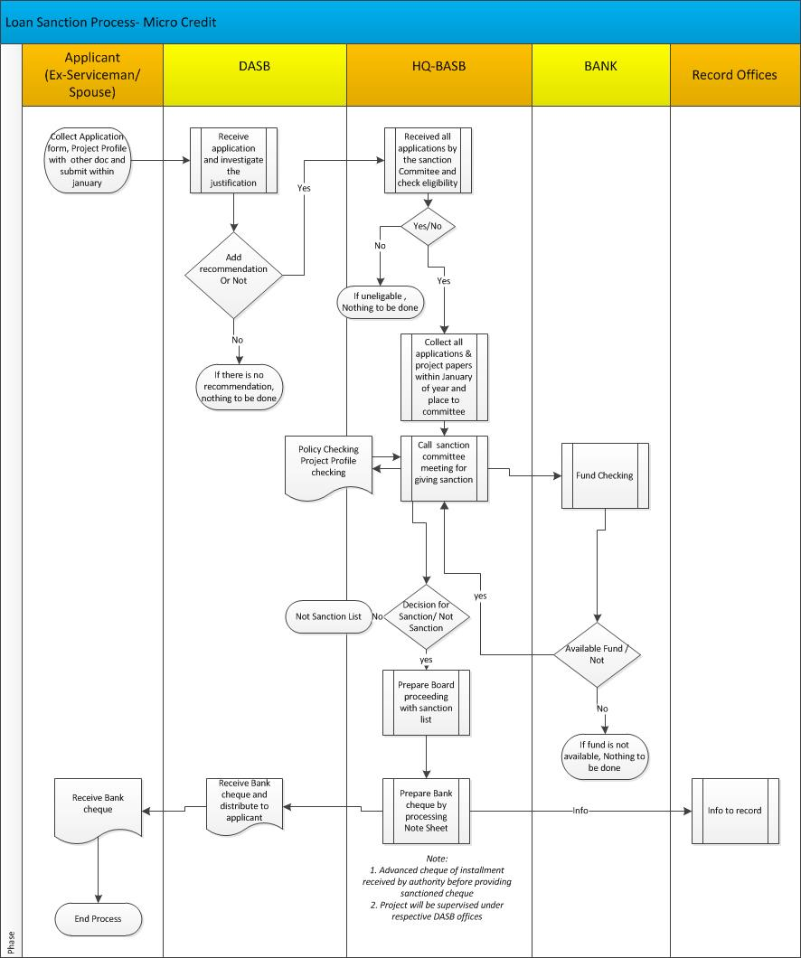

**Loan Recovery Process**

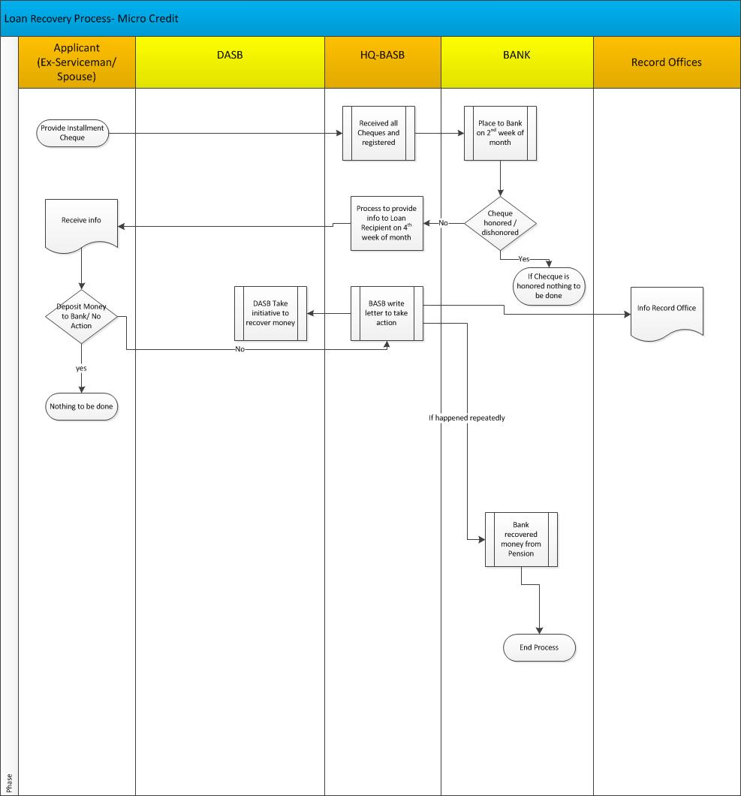

**To Be System:**

BASB has a micro credit scheme for it’s members and intend to manage in under the proposed System with following features:

* Eligibility;
* Application;
* Approval;
* Disbursement;
* Repayment;
* Waiver with due authorization in case of borrower’s inability to pay;

### Shanti Nibash Management

**Existing Business Process:**

**Overview:**

Home of Peace (Shanti Nibash) is a welfare activity of BASB for landless ex-Servicemen. It is a 100 seated rehabilitation center for landless ex-servicemen located at Rangpur. This old home is operated by the number of committees. A single ex-serviceman or his /her spouse who does not have any children or ignored by children can only apply for this service. There are two options for the applicant. One is ‘On payment’ and another is ‘Free of Cost’. In Payment based option, monthly charges for individual are set by the authority. Enrolment ratio of ‘Free of cost’ and ‘on payment’ is 75:25 and Army, Navy & Air ratio is 80:10:10. Interested ex-serviceman collect prescribed form from respective DASB or record office or BASB website for getting seat to the Old Home. After filling up of the form, Applicant submits to DASB office with supporting documents. Considering all policies, eligibility and availability of seat, the board takes decision against the request. Usually eligible applicant gets seat or keep him waiting for further decision. Donation from respective services, SKS , Donation from Other Organization , Aid from Government Source and amount collected from paying members are prime sources of fund for operating Old Home. Bank account is jointly managed by Deputy Director and Administrative Officer. All transactions are auditable by the pre-formed Board by BASB. All operational instructions are given in policy. The following major conditions are strictly maintained by concern authority while giving sanctions:

* Applicant must be the member of ex Bangladesh Serviceman their spouse and he/she does not have any income source
* Applicant or spouse does not have any land.
* Applicant did not participate any mission in service life
* Applicant got retirement before 1990
* Applicant does not have any children or ignored by them.

**Name of all Process:**

* Seat Sanction process
* Financial Management Process
* Administrative Process

**Major Actors**

* Ex- Bangladesh Serviceman or their spouses
* All DASB Offices
* HQ- BASB
* SKS
* Welfare Dte

**Cross Functional Diagram**

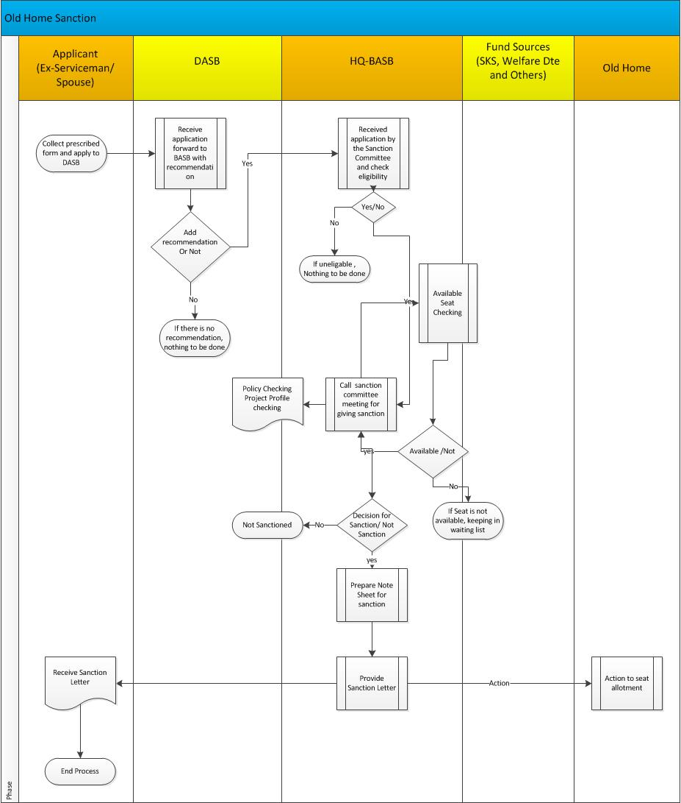

**To be System:**

BASB operates a home for senior members, management of which needs to be incorporated within the System.

### Shashastra Bahini Polly Management

**Existing Business Process:**

**Overview:**

Shashasra Bahini Polly project was established by the BASB to provide a permanent residential support for serving or retired JCO/OR/ equivalent member or their spouse (in special case) of Bangladesh Armed Forces. This project was implemented Gorahat, Dinajpur, and Thakurgaon on defence colony land under supervision of BASB. It is a one of the welfare activity of BASB.

Interested member of Bangladesh Armed Forces collects the form from respective DASB office. He / she submit application to the DASB office through proper authority. After completing proper investigation by respective welfare directorate and BASB’s security agencies and calculating the point table as per prescribed format, DASB prepare the list as per seniority and forward to BASB.

Considering seniority list and service proportion of allocation of plot, a lottery program is held for selecting the final list of allotted applicant. Generally, a group, consisting four people from same service is to be set against a plot. Again plot locations are defined by the lottery process. The sizes and location of plot are to be set considering current value and future prosperity of plot and it is fixed by the authority.

The following major conditions are strictly maintained by concern authority while giving sanctions:

* 50 % of plot value is to be deposited after getting sanction of the plot and rest of the money is to be deposited during registration process and expenses of registration is to be paid by the allotted member.
* If someone already owner of any type of plot from government / semi government, he /she is not eligible to apply for the plot of Shashasra Bahini Polly project. But if the plot has been sanctioned as compensation for acquiring applicant’s land by the government, he will be eligible to apply.
* Applicant must have eighteen year service experience. But the applicant, who retired before AI-2/88 circulation, must have fifteen year service experience. Besides, if service man sacrificed his life by attending the war, operation or the job of UN, his spouse is eligible to apply for plot.
* In case of Medical board recommended retirement, the serviceman must have at least ten year service experience.
* The serviceman, who suspended from the job, can not apply. (Even the retirement is consider as normal retirement by considering special case later on)
* Applicant must not have any verdict from civil court. (His spouse is not also eligible)
* Land allocation ratio among the army, navy and air services will be 8:2:2
* There are some other rules described in policy are strictly maintained to manage this system.

**To be System:**

BASB has a Polly management of which is needed to be done through the System, enabling them to:

* Application for land allotment
* Eligibility verification;
* Allotment;
* Maintenance of unallocated land inventory
* Handling of Improvement cost

### Funeral Management

**Existing Business Process:**

**Overview:**

Demonstrating appropriate respect and honour after the death of ex-serviceman, BASB arrange funeral program. The whole country is divided into nine areas to complete these activities. Some cell numbers, given in policy are always in service to give support. After finishing all formalities, a report is sent by respective DASB offices on specific format (Following information is described below) to the BASB.

* Serial No
* Core / Reg
* Address
* Responsible Base/Area/Unit
* Details of Expenditure
* Date of Birth
* Burial Place
* Amount

**To be System:**

BASB has a Funeral management of which is needed to be done through the System, enabling them to:

* Information can be distributed through system
* After completing the task, report can be forwarded through system
* All expanses can be proceed through system
* Record can be kept in system
* All information can be viewed on demand basis in real time

### Archive Management

**Existing Business Process:**

Hardcopy of exiting files are stored manually.

**To be System:**

Information which are not mandatory for regular usage of the application will be stored in the archive management module. Above mentioned information will also be accessible on requirement basis. For example, someone has applied for getting land lease basis and after finishing all the internal process the application has been approved and finally the land is handed-over. At last all information associated with this land application will be stored in Archive.

BASB requires a systematic document management system to accommodating office documents electronically and archiving the same.

Features would be:

* Archiving documents with appropriate indexing.
* Ability to retrieve the document through mete data search
* Automated expiry rule based archiving

Outcome of the module:

* Easily retrievable information from the system.

### Accounts Management

**Existing Business Process:**

**Overview:**

BASB maintains the following major funds to execute its dealings regularly:

* Public Fund
* Defence Colony Development Fund
* RCEL Fund
* Private Fund

BASB keeps and maintains all records of accounts for run activities smoothly. The accounts are operated as per respective policy. This section deals DASB’s regimental audits. To spend the money, registers are maintained for obtaining approval from authority and keep all records for further references. Periodical audit is accomplished as per policy. To maintain all revenues come from BASB or DASB accordingly.

**To be System:**

After each financial year, DASB submits the bills/ invoices supporting the allotment/ expenditure in a prescribed format to the BASB HQ.

A solution needs to be designed keeping in mind the followings:

* + - Accounting of all activities;
    - Vouchers, Trial balance, ledgers;
    - User configurable account reports;
    - Bank Reconciliations;
    - Financial consolidation of all location on real time basis;
    - Audit trails and drill down to source transaction;
    - Grant Management;
    - Welfare Payment Management
    - Asset lifecycle Management;
    - Procurement.

Outcome of Account Management Automation:

* + - Accounting for all activities, tracking the Budget utilization, Disbursement, expenses on a granular level;
    - Accurate real time information covering all locations and all transactions;
    - Ability to track and review of transactions of all locations
    - Reports can be generated at any given time;
    - User definable reports and queries from system front end (without using SQL or other IT tool)
    - Same information will be shared across the organization at the same time;
    - Accounting transactions can be trailed by login parameters and controlled through assigned role profiles;
    - Eliminate requirement for reconciliations;
    - Easy sharing of information;
    - End to end Audit trail of all transactions

### Budget Management

**Existing Business Process:**

**Overview:**

Head Quarter, BASB carries out all budget activities throughout the year. Initial Budget demand, allotment and sub allotment for BASB and DASB are ensured by the concern personnel. All bills are placed to FC (Army) in due time and coordinate for approval from concern authority. Monitoring the expenses on quarter based and ensures proper utilization of allocated budgets in time. Coordinate with establishment branch of HQ to ensure all expenses in time. Ensure pay and Allowanceof defence and civilian personals. Process related to TA/DA bill is done by this section.

**To be System:**

BASB receives yearly budget allotment from MOD for welfare activities, BASB disburse these allotments to all DASB for onward allotment and expenditure throughout the year. Budget Management features should be as follows:

Features are as follows:

* + - Multiple parallel Budgets
    - Planning and allocation of Budget;
    - Disbursement of budget as per allocation;
    - Budget, variance periodical reports and reconciliation;

Outcome of Budget Automation:

* + - Budgetary control for all transactions;
    - Multiple budgets to be active at the same time and transaction can be validated against any budget;
    - On demand report showing budget versus actual at that point of time;
    - Reliability of information across the organization;

### Leave Management

**Existing Business Process:**

At present all leave correspondences and associated information is operated manually and maintained on hard copy.

**To be System:**

Following sub module can be considered to develop this system:

* + Leave type setup
  + Leave Allocation
  + Leave Approval
  + Leave Limit
  + Leave Forward
  + Leave Encashment

### Daily Correspondence Management

**Existing Business Process:**

At present all correspondences and associated information is maintained on hard copy.

**To be System:**

BASB requires all routine correspondence within all branches offices and HQ to be done through integrated Mailing System.

Features of the system would be as follows:

* + - Internal Communication within BASB HQ and DASB;
    - Communication to its members based on their medical checkups/ follow ups/ reminders;
    - Events, social activities through web and email communication;

Outcome of the application:

* + - Routine correspondence automation;
    - Electronic communication will minimize paper and file management;
    - Members can be easily reached with events and social activities.

BASB requires a Customized HR management system catering to specific BASB requirements

covering the following:

* + - HR administration;
    - Payroll including payment of Pension and one time benefits
    - Leave Management;
    - Personnel movement management;
    - TA/ DA, etc.

Considering all module activities the following sub modules can be also considered for the system:

**Admin Matter:**

* + - Audits
    - Orders Management (Prep different type of orders and forward to Area, Division, MoD and Station)
    - Performance Management (OPR, ACR, Part-II of all ranks)
    - TA/DA Bill- all ranks
    - Handing/Taking
    - Publishing of Part-1 & part -2
    - Discipline
    - Demand Management

**General Matter:**

* + - Arrangement of Visit/Conference
    - Initial correspondence for preparing Passport/ID/Visa etc

**Quartering Matter:**

* + - Correspondence for Arms/Ammo, official Land, Furniture, Accommodation, vehicles, Condemnation Board, MES etc
    - Local Purchase
    - Annual Stock Taking/Survey, Tech Insp
    - Process for Ration
    - Gen (Misc) Corres

BASB will do all routine correspondence within all branch offices and HQ through this integrated mailing system. Following plan can be implemented:

* Communication to its members based on their medical checkups/ follow ups/ reminders.
* Events, social activities through web and email communication.

### Movement Management

**Existing Business Process:**

At present all correspondences and associated information is maintained on hard copy.

**To be System:**

This module will help to manage and record on the internal –external movement process and status of existing employees of BASB. Some of the features are:

* Create official visit order
* Keeping record of visit information
* Manage Approval process of all official visit orders

### Policy Letters Management

**Existing Business Process:**

At present all correspondences and associated information is maintained on hard copy.

**To be System:**

This module will help to manage all sorts of policies dynamically of the overall application. Some of the features are following:

* Create policy
* Modify policy
* Make policy active or inactive
* Map policy against certain modules
* Define rules for policy

### Monthly Activities Management

**To be System:**

The proposed system will be an integrated in-house developed software solution to automate all BASB’s activities. Using this module authority can avail to monitor all activities on text and graphical mode.

List of monthly activities assigned to district levels which needs to be automated for follow-ups and measure progress of the same.

Followings are major features of this module:

* It records day to day financial activities in electronic format and then produces management monitoring reports at required frequencies
* It will be flexible enough to cater the needs of BASB’s operations standardized MIS reports for each level of users.
* Monthly activities of all modules and sub modules will be visualized through the system.

### Daily Vehicle & POL Management

**Existing Business Process:**

At present all correspondences and associated information is maintained on hard copy.

**To be System:**

**Daily Vehicle**

BASB requires a Vehicle management system to ensure smooth operation of the same managing the followings:

* Fuel Consumption;
* Maintenance and servicing, etc.

This module helps to manage all your vehicles, the contracts associated to those vehicle as well as services, fuel log entries, costs and many other features necessary to the management of your fleet of vehicle(s).

Some of the features are:

* Add vehicles to your fleet
* Manage contracts for vehicles
* Reminder when a contract reach its expiration date
* Add services, fuel log entry, odometer values for all vehicles
* Show all costs associated to a vehicle or to a type of service
* Analysis graph for costs
* Request and approval process for vehicle booking

**POL Management**

Store and inventory management should be captured in the system in the following manner:

* + - Issuance/ distribution of POL;
    - Balance inventory in a given time/ period;
    - Reconciliation;

Outcome of Store Inventory Management:

* + - Stock position at any given time;

### Daily Programme Management

**Existing Business Process:**

At present all correspondences and associated information is maintained on hard copy.

**To be System:**

All programs will be defined through the system. Following features to be considered during development of the proposed system.

* Define Holiday Class
* Personnel Sub area
* Define Break Schedule
* Define Daily Work
* Define Period Work Schedule
* Define Day types
* Define Employee Sub group groupings
* Define Grouping for the Public Holiday Calendar
* Set Work Schedule Rules & Work
* Generate work Schedules Manually.
* Set Default Value for the Work Schedule

### Monthly /Quarterly/ Half Yearly / Yearly Reports Return

### Management

MIS as per present requirement of the MOD/ BASB HQ in the following heads:

* Monthly activities;
* Daily Program;
* Monthly, Quarterly, Half yearly and Yearly reports and returns thereof;
* Monitoring of welfare activities.

**Outcome of Query and Reporting:**

* Single point of Trust and accuracy of reporting across the organization;
* Presentation of information as required by HQ/ Donors;

### All Application forms USED IN BASB for welfare Activities are attached here

To be attached

## Hardware & Networking

### List of Hardware

|  |  |  |  |
| --- | --- | --- | --- |
| **Ser** | **particulars** | **Qty** | **Unit** |
|  | Blade Server Chassis Specification | 2 | Nos |
|  | Application Server Specification | 6 | Nos |
|  | Web & Mail Server Specification | 4 | Nos |
|  | Multi Purpose Server Specification | 2 | Nos |
|  | Active Directory, Backup Active Directory, Anti Virus, Backup Management Server Specification | 4 | Nos |
|  | SAN Storage System Specification | 1 | Package |
|  | Backup Solution Specification | 1 | Package |
|  | Core Router | 2 | Nos |
|  | Core Switch | 2 | Pcs |
|  | Core Firewall | 2 | Pcs |
|  | Floor Access Switch | 2 | Pcs |
|  | RAISED FLOORING SYSTEM | 1 | Package |
|  | ELECTRICAL WORKS (AIRCON, UPS, LIGHT, Etc.) | 1 | Package |
|  | FIRE RATED DOOR | 1 | Nos |
|  | DEHUMIDIFIER | 2 | Nos |
|  | AUTOMATIC FIRE SUPPRESSION SYSTEM | 1 | Package |
|  | SURGE PROTECTION DEVICE | 2 | Set |
|  | RODENT REPELLENT SYSTEM | 1 | Set |
|  | ACCESS CONTROL SYSTEM, BIOMETRIC TYPE | 2 | Nos |
|  | IP SURVEILLANCE SYSTEM | 8 | Nos |
|  | UPS System (Online) | 2 | Pcs |
|  | Air Conditioner | 2 | Pcs |
|  | Server & Network Rack | 3 | Pakage |
|  | Structured Cabling | 1 | Package |
|  | INTELLIGENT / STATIC TRANSFER SWITCH | 1 | Pcs |
|  | ENVIRONMENT MONITORING SYSTEM | 1 | Package |
|  | Workstation Computer | 50 | Pcs |
|  | Laptop Computer | 4 | Pcs |
|  | Branch Router | 45 | Nos |
|  | Line Interactive UPS | 50 | Nos |
|  | Printer | 47 | Nos |
|  | Scanner | 47 | Nos |
|  | Computer Table & Chair | 50 | Nos |
|  | Branch Readyness | 45 | Nos |
|  | Connectivity | 45 | Nos |

### Networking with Outlet configuration

**Data Connectivity.** All the district offices of BASB are being connected with the head office. As a result, all the offices will be able to function under a single database system instead of maintaining separate database in separate server. This will make the software maintenance and database system easier and consolidated report can be generated instantly. BASB head office and all its offices currently are not directly connected each other. After set-up of network connectivity among each other which will bring all offices and head office under an umbrella.

### Data Center

**Set-up of Data and Service Support Center.**  Under the BASB improvement & expansion ICT plan a high tech data center will be built at the head office of BASB Kakrail and all DASB office premises. At the initial stage, the data center will be established on a premise of 2000 sft area and all kind of safety and security will be ensured through physical manning and installation of disaster prevention equipment (such as: Smoke Detection and Auto Suppression, Precision AC, Environment Monitoring System (EMS), Access Control System etc). It will be built in phases. Meanwhile, construction of all physical infrastructures and installation of machineries have been completed. Remaining will be completed within the schedule time frame.

### Digester Recovery center

**Disaster Recovery Site (DRS).** The overall activities of BASB including its services are being conducted through the computer system. Hence, software and data which are being used in this server system are considered to be very crucial. Since the server system and the software and data being used are very valuable and significant, the backup system must be vary resilient and secured. It is very essential to keep up continuation of services uninterrupted. A Disaster recovery site (DRS) is required to be built up with a view to ensuring the uninterrupted service to customer. The DR site should be built at a far different geographical place. According to the ICT guideline of the Bangladesh Government, the distance between the data center and the DR Site must be at least 10 km. However, as it is time consuming and expensive to build and maintain such a DR site alone, it has been planned to build this DR site jointly with Armed Forces and other institutions.

## Suggested Development Technology and Tools

**Development Technologies:**

* Front end Language : HTML5
* Scripting Language :JavaScript, Jquery
* Front end Style :CSS3
* Back end Language : PHP/Python
* Application Framework : MVC
* Database : MySql 5.5 or later/PostgreSQL 8.0 or later
* Application Server : Apache Server

**Development Tools:**

* IDE : Eclipse
* Testing tools : As described
  + Load Testing : JMeter
  + Security Testing :OWASP
  + Performance Testing :JMeter
* Source Control Tool :Git
* Project Management Tools :Scrumwise/Mingle/Project Open

## Suggested testing method for Acceptance

**Project Testing / Embedded Testing**

Following tests will be carried out for Acceptance Test of the proposed System Software developed by the developer firm prior to the Acceptance of the Software:

* **Integration Testing-** Carried out either as one-off (that is, when all integration is

completed) of incrementally (that is, whenever one unit of software integrated and continued till all units are integrated). Black Box testing is used in one-off Integration. Testing and white box testing can be, perhaps, used in incremental integration testing.

* **System Testing-** To ensure that the software works in all intended target systems.
* **User Acceptance Testing-**  To obtain customer sign-off so that software can be

delivered and payments received, optionally, many other tests can be conducted at the behest of the customer.

* **Product Testing-** Product would be developed as a project first and would undergo all

the tests that a project normally undergoes, namely, unit, integration, and system testing.

* **Load Testing** – in web applications and multi-user applications, large numbers of

users are logged in and try to use the software in a random manner.

* **Functional Testing** – test that all functions expected of the software are functioning

correctly.

* **End-to-End Testing** – in this type of testing, one entity is tracked from birth to death in

the application.

.

* **Stress Testing** – cause stress to the software by making expected resources

unavailable or causing deadlock.

* **Positive Testing** – test the software as specified and not trying any negative acts – to

ensure that all defined functions are performing. Used mostly for customer / end user acceptance testing.

* **Negative Testing** – using the software in a manner that is not expected to be used –

this will bring out all hidden defects in the software.

* **Deployment Testing** – Simulate the target environment and deploy the software and

ensure that deployment specified is appropriate.

* **Sanity Testing** – This cursory testing to ensure that the components, of software

package, are complete and are of appropriate versions, carried out before delivery or before making a software-build.

* **Regression Testing** – Testing carried out after unearthed defects are fixed
* **Security Testing** – Testing to ensure vulnerability against the threat of viruses and

spy-ware

* **Usability Testing** – Testing the software for different types of usage to ensure that it

satisfactorily fulfills the requirements of specified functional areas

* **Install / uninstall Testing** – Test the software on all target platforms to ensure that

install and uninstall operations are satisfactorily performed

BASB may carry out some combination of the types of testing described above, some of them are as following types of testing –

* **Functional Testing-**To ensure that all the functionalities allocated to the software are

working and there are no inaccuracies, when used properly.

* **Integration testing** – To ensure that the coupling between various software modules is in

order.

* **Positive Testing / Acceptance Testing-**To get the software accepted by the client.
* **Load Testing**- to ensure that the system does not crash when heavy loads are placed on it

## Concept of Security System

The proposed security system must be very robust, reliable to ensure the protection of the software and others from perceived risk. Besides the standard features, additional security measures to be integrated by developer. Here are some guidelines:

**Security Features**

**Presentation Layer Security.**

* + - Login/Password (email as Unique ID)
    - CAPTCHA: Verification code has to be entered as appeared in the ‘CAPTCHA’ and this is used to avoid automatic creation of users and to ensure that users are created manually.
    - Session level security

**Transmission/Transaction Layer Security.**

* + - Secured Socket Layer (SSL – 128 bit encryption)
    - Domain/Server level Session security
    - Electronic Signature/ Digital Signature based authenticity

**Application Layer Security.**

* + - Secure Coding Concepts will provide

Error & Exceptions handling.

Input Validation.

Memory Corruption Detection.

* + - Cross-site Scripting Prevention.
    - Remote Code Execution Prevention.
    - Path Disclosure Prevention.
    - Secure Credential/password/secret questions and answers storage for challenging the system users.
    - Web services to be used to access different processes and services offered by different modules of the applications.
    - Message to be transferred using XML/Json packets.
    - SQL Injection protected.

**Database Layer Security.**

* + - Bitwise encryption while streaming to and from database (bid box).
    - Confidential data like identity information to be tagged by MD5 for integrity.
    - Data Loss Prevention (DLP).
    - Data Recovery Plan (DRP).
    - SQL injection proof data access codes to be written.

**Hardware Layer Security.**

* + - 2 layer Firewalls to protect e-DP System access from Internet and LAN.
    - Database to be kept in Intranet IP class behind firewall and application server to be kept in Public IP class
    - Database to be clustered.
    - Hard drive to use RAID 5 hot swappable storage technology.
    - Daily Data backup process to be automated.
    - Mirror server to be hosted.
    - Cable Locks, Data Centre Safety & Locking Cabinet to be physical security.

**Workflow Based Security.**

* + - Only authorized and authenticated users to have access to specific level of workflow.
    - Procuring Entity to have rights to manage users as per their needs.

**Host Security**. It must include following:

* + - Operating System Security and Setting.
    - Anti-Malware.
    - Hardware Security
    - Host Software Base Lining.

**Application Security**

|  |  |
| --- | --- |
| **Application Security** includes the followings:   * Secure coding concepts   + Error and Exception handling   + Input validation   + Memory corruption detection * Cross-site scripting prevention * Cross-site Request Forgery (XSRF) prevention * Remote code execution prevention * Path disclosure prevention * SQL injection prevention * Secure credential/password/secret questions and answers storage   SSL, cookies with secure flags, cookies with http only and STS |  |
| **Data Security** includes the followings:   * Data Loss Prevention (DLP) * Disaster Recovery Plan (DRP) * Data Encryption | C:\Users\administrator\Desktop\fig1.gif |
| **Host Security** includes the followings:   * Operating system security and settings * Anti-malware   + Host-based firewalls * Hardware security   + Cable locks   + Data Center Safety   + Locking cabinets * Host software base lining | Ff648651.f15thcm01(en-us,PandP.10).gif |

## Application Architecture

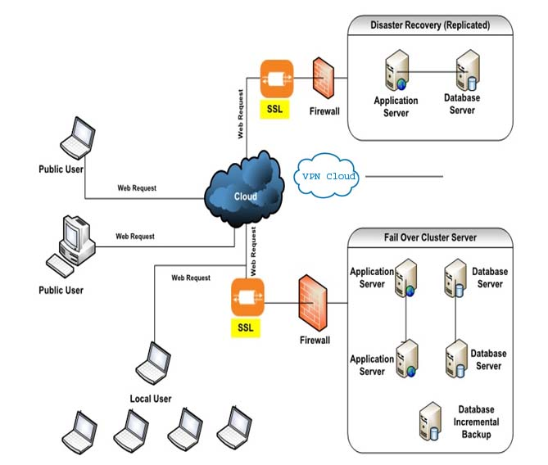

## Implementation Activities

|  |  |
| --- | --- |
| **Pre-Installation** |  |
| **Installation** |  |
| **Post Installation** | **post -application.jpg** |

# Training

The ICT personnel are being imparted training for improving their efficiency. A modern training center has been set up to provide training to its manpower. A committee has been formed under the leadership of the Director of the Board with a view to reviewing and monitoring the proper implementation of ICT Plan. At every regular meeting of the Committee necessary directions are given and other decisions are taken along with the reviewing of the progress of the implementation of the Plan. Besides, the Board is being apprised regularly about progress of implementation. Finally the proposed ICT plan is expected to achieve the following objectives:

* + - An efficient and effective ICT setup will be developed to provide efficient services of BASB.
    - Different types of software modules have been developed for different purposes since 1998.
    - Some modules were developed using different tools and platforms. These are planned to be brought into a uniform platform to make the integration easier and effective.
    - Online data connectivity will be established between all offices of BASB located in different parts of the country. All offices will be able to work under single database environment. As a result, any consolidated report or statement could be readily available in this system.
    - A state of art Data Center (DC) will be built at BASB Head Office to modernize the ICT physical infrastructure for smooth service delivery to its customers. All kinds of machineries and equipment will be installed to prevent any sorts of disaster with the view to ensuring the optimum uptime of the system.
    - A Disaster Recovery Site (DRS) will be built at a suitable place in order to provide uninterrupted customer service and to prevent any kind of disaster.

Training needs to be facilitated among the BASB staff so that they can easily adopt System functionalities and procedures.

**General Feature:**

* + Ensure Training environment;
  + Integrated BI tools without additional cost or licensing;
  + Configurable key user dashboards with option to create custom dashboards
  + Unlimited budget versions with expenses validation available for each of the budgets;
  + All modules available with user license without module wise additional cost;
  + AMC for the software including entitlement for free upgrade of license to latest version
  + Flexibility and integration to other products in the Microsoft portfolio.

#### Training Approach & Methodology

The overall scope of the training program is outlined below:

* + Identification of training needs and development of training plan;
  + Development of training material;
  + Conduction of training;

The overall training scope is further divided into the following tracks:

* + Functional track;
  + Technical track;

Each track will have a defined curriculum and expectations and will have its separate participant profile. The entire training will be conducted on a “train the trainer” basis. Development and BASB business team will jointly identify the select list of people from among the core and business user community who will be trained by the bidder. These select participants aptly called “Module Champions” would then take the ownership of the system and in turn train the other end users of the client.

The various training programs are summarized below:

|  |  |  |  |
| --- | --- | --- | --- |
| Ser | Training | Target Group | Objective |
| 1 | End User Functional Training (Hands-On training) | Core Team, user of the system | To impart the knowledge of the Mapped functionalities of the application to the core team so as to equip them with the knowledge of the application as per the business processes. This will enable them to own the application and in turn provide training to any other users of the application. |
| 2 | End User Technical Training (Hands-On training) | Core Team (Technical) System Administration | To impart the knowledge of the technical aspects of the application to the core technical team so as to equip them with the technology of the application. This will enable them to address any technical requirements of the application and be in turn provide training to any other technical users of the application |

# Existing Sates and Reports sample as annexure

# Deliverables

The list of deliverable may as under:

* Project & Progress Plan
* The Total BASB Automation System Developed According The Modules Installed In Phases and Commissioned.
* Additional Special Modules as required
* Database Management
* Hardware Specifications for Installation Preparation
* All Coding Used In the System Development and Code Documentation.
* User’s Manual Both Online, CD and Hard Copy Form
* Training for End Users, Executives, and System Admin as Per Approved Plan.
* Technical Documents on Software Development (All Modules)
* System Design Document
* Data Schema
* SQA Report
* Test Result for Each Software Deliverables
* Acceptance Test Result for each Software Deliverables
* Architectural Document for Total System
* Functional Description
* Configuration Information
* Interface Connections
* System and Sub System Schematics Diagram
* Overview of Build Requirements.
* System Requirements.
* Software Installation, Maintenance & Service Support
* Software Versions with Documentation
* Communication Interface Protocols
* Test Plan, Case Procedures and how to use
* Rollback Procedure and how to load Data
* Maintenance Procedures and System Support Procedures